**Realization of the Einstein-Infeld idea**

This work aims to realize the Unification Theory by firstly requesting the reformulation of two fundamental laws of the Theory of Relativity and of Quantum Mechanics. This is necessary because the current form of these laws cannot bring closer the above-mentioned theories. Here we define a new energy term – the exposed energy – that allows to derive all the laws of classical mechanics and special theory. The **exposed energy represents the field of an object and this realizes the idea of Einstein-Infeld**. Here in this summary we first introduce the concept of the exposed energy and an elegant new way to rewrite the energy conservation law. Then after establishing the idea of the field of an object we introduce the mathematical apparatus that is used to derive the physical quantities. The laws that are reformulated are:

1. **The energy conservation law presented by Einstein in the Special Theory;**
2. **Heisenberg’s Uncertainty Principle.**

**1) Reformulation of Einstein’s energy conservation law**

**The central idea**

This work analyses the Einstein postulate that emphasizes the constant character of the speed of light. This postulate is replaced in this work with a postulate that emphasizes the constant character of energy, and energy is seen as an intrinsic characteristic of a material object that is independent of the form, type or speed.

**The central idea emphasizes** that as a force is exerted on an object, there is no change in its mass or its energy. There is only a transformation of the energy which remains constant. The object changes only its attributes such as inertia, an attribute that should not be confused with the mass or the energy. **An object does not change its energy but only its energetic state,**  which exists even for an object at rest and its presence is asserted by the existence of forces such as electrostatic or gravitational force.

**The realization of the theoretical idea**

An object with a defined mass and energy transforms its energy as the velocity changes. The part of the energy that is transformed is called the **exposed energy** ($E_{exp}=mc^{2}\left(1-\sqrt{1-{v^{2}}/{c^{2}}}\right)$), whereas the other part is called the **unexposed energy $E_{unexp}=mc^{2}\sqrt{1-{v^{2}}/{c^{2}}}$** . The sum of these two energies is a constant quantity which is called the total energy of an object, $E=E_{exp}+E_{unexp}=mc^{2}$.

One can find the expression for the momentum by taking the derivative of the exposed energy – that represents the field of a material object - with respect to the velocity : $p={dE}/{dv}={mv}/{\sqrt{1-{v^{2}}/{c^{2}}}}$ (valid for relativistic and classical physics). If we take the derivative of this momentum wrt the time, one can find the expression of the force for both classical mechanics and relativistic mechanics : $F={dp}/{dt}={ma}/{{\left(1-{v^{2}}/{c^{2}}\right)}^{3/2}}$.

After the intersection of the curves, the idea of Wheeler to measure based on a quantum theory of gravitation is materialized. After the intersection point, all the space parameters have a quantum character.

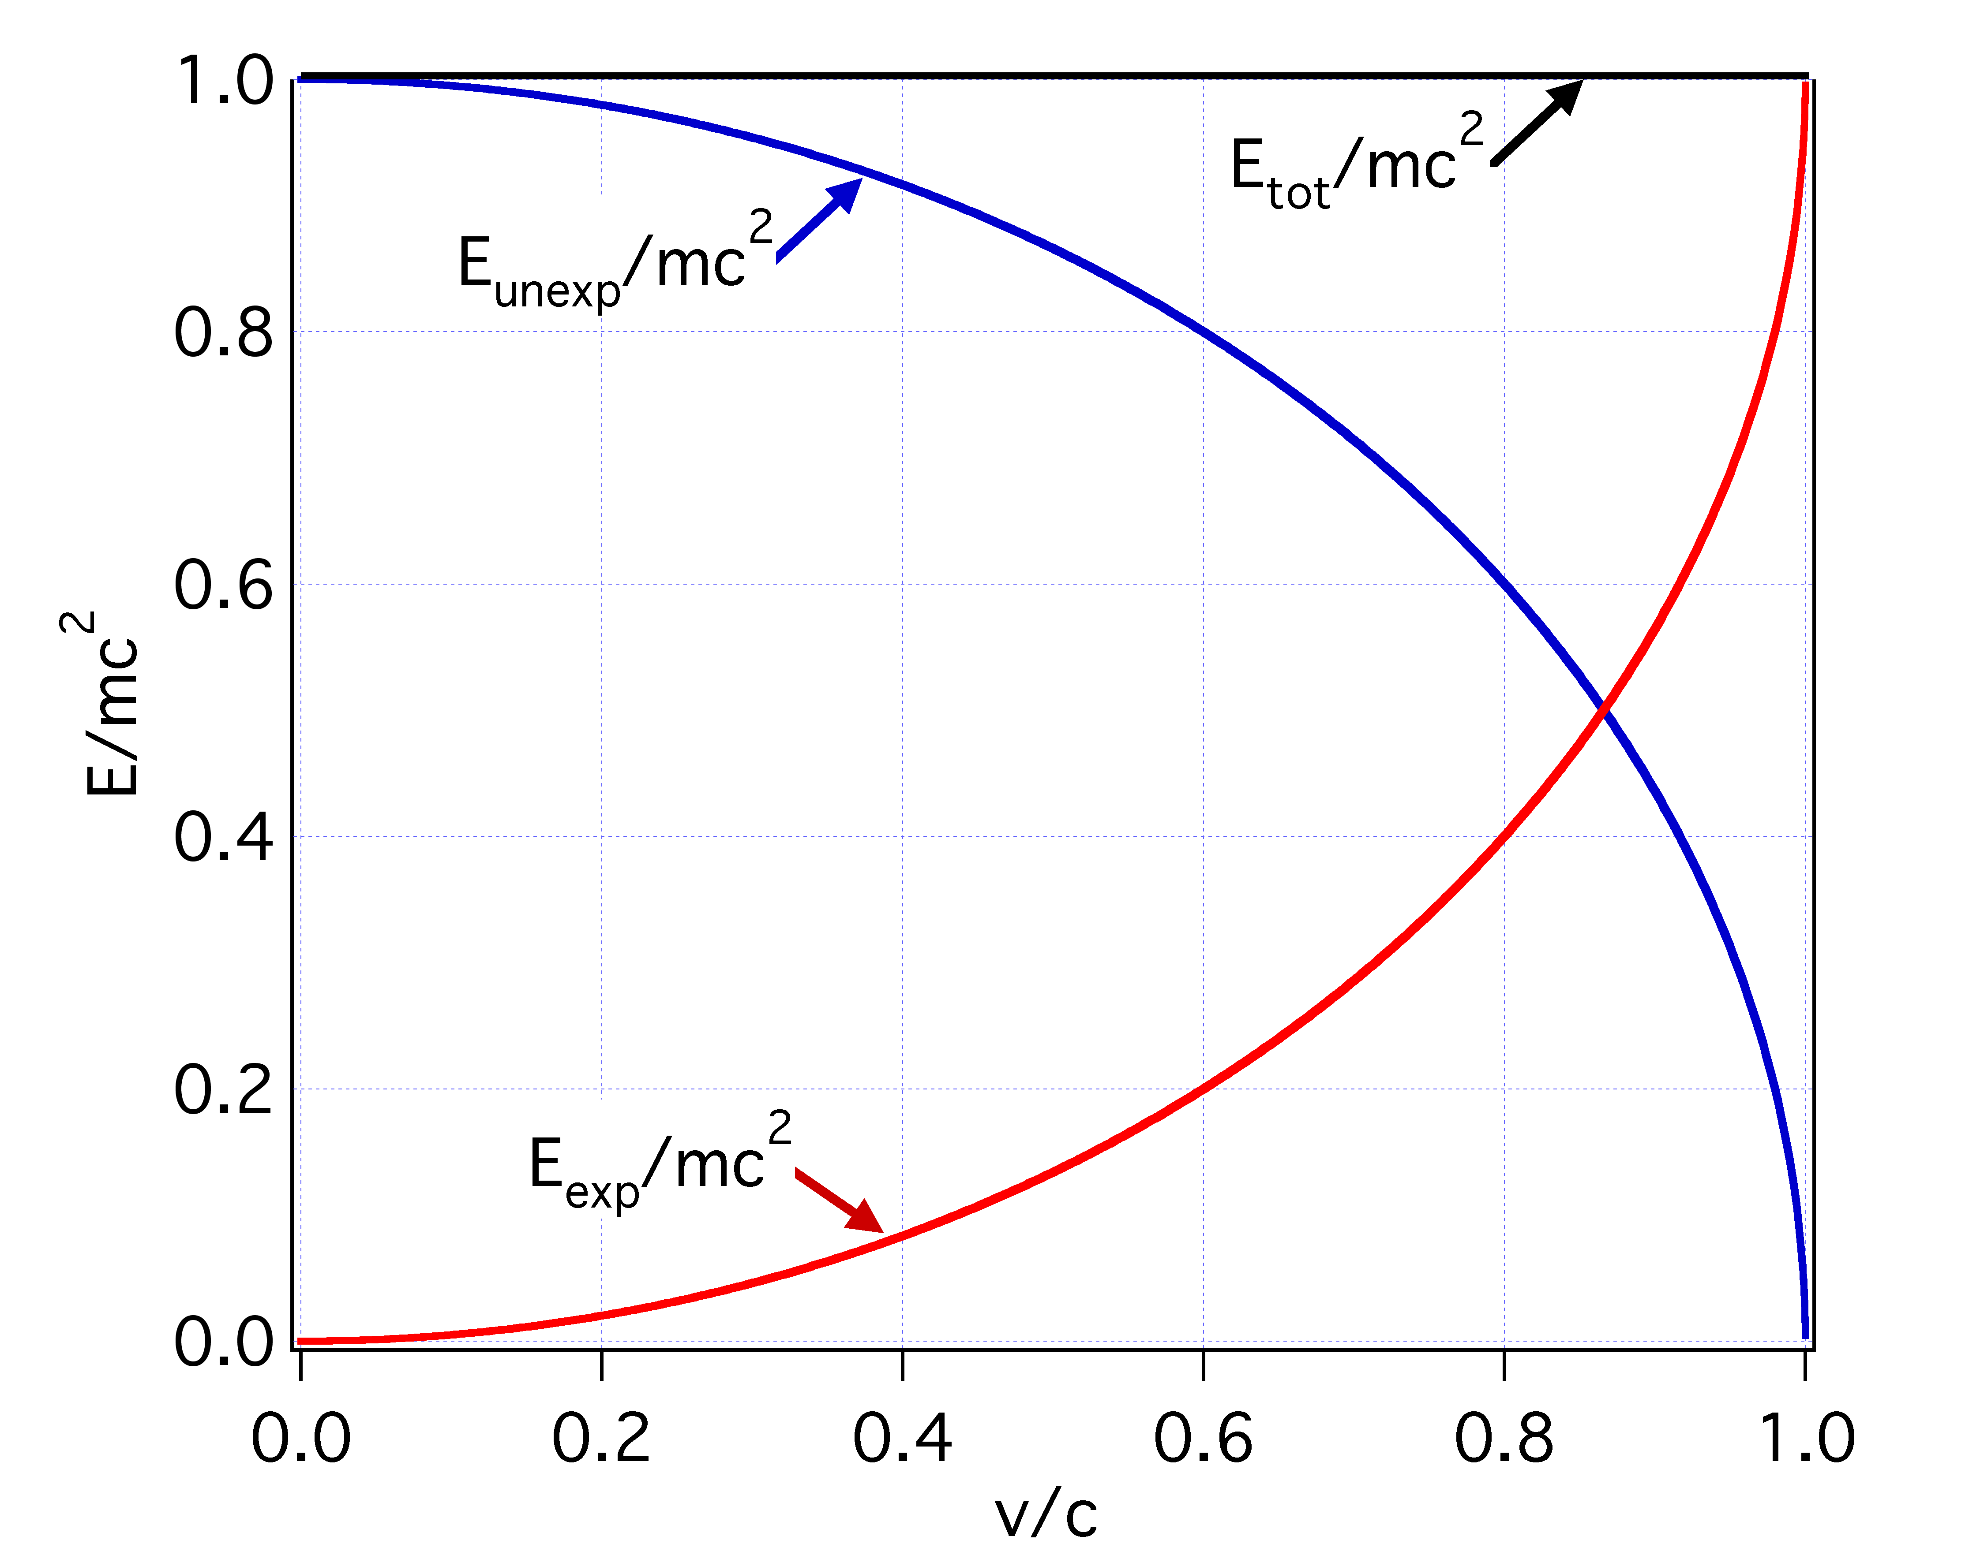

Fig. 1. The exposed (red) and unexposed (blue) energy as a function of velocity and their corresponding momentuma.

**Checking the accuracy of the new form of the energy conservation law**

Checking the accuracy of the new form of the energy conservation law is done, as in all the other theories, through the use of the Lagrangian which uses the expression of the exposed energy and provides the equations of motion for both classical and relativistic mechanics. $L=\left(1-\sqrt{1-{v^{2}}/{c^{2}}}\right)mc^{2}-V\left(x\right).$

To find the equantions of motion one can use the Lagrangian. According to what was formulated above, it is the exposed energy that governs the events. By taking the derivative of the exposed energy, we can get the law of momentum and from the latter we can derive the force. The exposed energy as defined in Eqn. 11, allows to construct the Lagrangian.



Einstein does not employ the use of Lagrangian in special theory. The arguments for this, that is in fact very important based on the role that it plays, could be different and we could hypothesize one of them. Based on the idea that leads to its mathematical formulation, the Lagrangian is related to the least action principle. Formulated a long time before the special theory, we use it in our new formulation to derive the equations of motion. The form of the Lagrangian used in our work is simpler and much more easily adoptable than that of the special theory and this for a simple logical reason. This work is constructed based on the property of the energy that has the capability to describe or analyze all types of motion. We present here in a general form the laws of motion.



The formulation of the law of momentum for large velocities is given above. For () we derive from the Lagrangian given above to the Lagrangian that is used in classical mechanics.

(; )







From the relation above we can derive the expression for the kinetic energy:



By substituting the force in the equation above we write:



By substituting  from which we get , and if we do all the rest of the calculations we get the formula of the relativistic kinetic energy:



We find the expression of the kinetic energy of the special theory with the help of the Lagrangian. This achievement does not have only an aesthetic character. We could have found this expression using an indirect way, i.e. finding first the momentum and then the force. The latter is the essence of the expression of the relativistic kinetic energy. In a more general way of expressing, the expression of the kinetic energy, similarly to the force, is lower than the hierarchical rank than the momentum. We can not find the formula of the momentum by taking the derivative of the kinetic energy momentum with respect to speed.

The purpose of our work is to reduce the importance of the kinetic energy and the role that is attributed to it, or the role that it takes in the formulation of the law of conservation of energy. The latter does not quite need it, because relies on the property of the energy, which in contrast to the kinetic energy does not depend on the form, type or speed of motion.

The comparison between the two types of energy, kinetic and exposed, is reported here for the sake of the concern that exists from the interpretation of the experimental results in accelerators. We emphasize that the increase of the resistance coming from the object due to its countervailing force is a result of the exposed energy. With the force the energy of an object does not increase, but only its energy state is changed. It is true that Einstein demonstrates that the formula of kinetic energy of classical mechanics is valid only for small speed, but it does not mean that the mass of motion increase. What we observe in accelerators is the fact that in order to keep increasing the exposed energy we need a force that increases more and more.

**The theoretical achievement**

We can eliminate the infinite quantities that are seen as the cause of the difficulties in achieving the Unification Theory.

1. The expression for the momentum that is postulated by Newton and then by Einstein is found here by using the derivative (taking the derivative of the energy).
2. We create a functional scale of laws **energy-momentum-force**, that cannot be achieved from current physical theories. This then leads to a new formulation of Heisenberg’s uncertainty principle.

**2) Heisenberg’s Uncertainty Principle**

**The central idea**

The creation of a functional scale of the laws **energy-momentum-force** allows one to conclude that the forces on an object when at rest represent the **minimum energetic state of a material object**. The larger energetic states are multiples of the lowest energetic one, similar to the minimum currency denomination of any country, until the energetic state equals the general energy of an object. The functional scale allows calculation of the parameters of the state at rest, a calculation that cannot be accomplished using Einstein’s energy conservation law or the concepts in quantum mechanics. We stress the importance of differentiating the concept of the energy of an object and the work done on an object. In quantum mechanics no energy state is attributed to an object at rest, but is postulated by emphasizing that a particle is never at rest.

**The theoretical achievement**

The new law that represents the Uncertainty Principle has in its essence the Planck constant and the fine structure constant. The latter relates the state at rest with the state of minimum action which is characterized by the Planck constant.

The greatest theoretical achievement is the dropping of not only the elementary charge but also of the Newtonian gravitational constant.

Einstein presented the idea that considered an object as a field moving with the speed of the object. We formulate this idea as follows: Once an object with a certain mass and certain radius is “created”, we do work by continuously adding infinitesimally “thin layers” composing an object step-by- step from a small radius up to the total radius. If we integrate this work (and consider the energy of gravitational character) we find an answer of the order E~Gm2/r (more precisely 3/5Gm2/r). This work done “to construct the mass” makes itself present around the mass in the form of a field force that decreases with the square of the distance. (The work done to make up the mass is equal to the energy of the object that it exhibits around but not localized within the physical boundaries of the object) This approach can be considered as the The force that this object exerts is directly linked with the energy of the object through a space parameter. In order to find the exact value of the force, we use a “reference point”, or a “reference parameter.” Similar to the discussion of the electric force that is ‘zero’ as the distance diverges to infinity, we consider the force to have a maximum value when the space parameter is equal to the Planck length.

**Practical use**

**The fundamental equation *mcr = aħ*, allows calculation of the minimum and the maximum energy state of objects in nano- and macroscale.** Using this equation, we can calculate the minimum and maximum space parameters for all objects as a function of the mass. Using these space parameters, we have calculated all the other parameters including the force.

There is critical aspect that we have considered. The expression ***mcr = aħ*** is used differently on both sides of the Planck’s mass (***mP***). The point of the intersection of the space parameter curves is considered to the inversion point. For masses larger than the Planck’s mass instead of ***mc*** we use ***1/mc***. Just recently we came across a work of Bartini where he uses the concept of inversion point and he uses the notion of inverse of physical quantities.

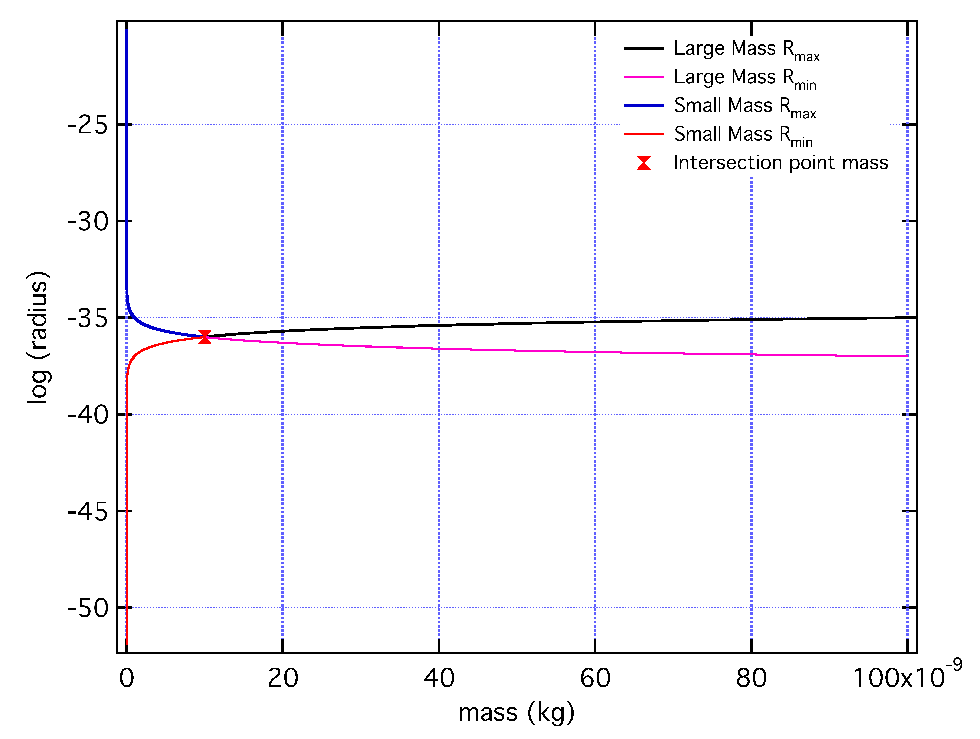

Fig. 2 The maximum and minimum space parameters as a function of the mass.

The use of the term ***mc*** (***rmax = aħ/mc***) that is equivalent with the linear momentum and its inverse ***1/mc*** (***rmax = mcaħ***) is directly related with the space parameter ***r*** and this space parameter is related to the field of the object. From the field of the object we derive the force using ***Fr=mc2***.

|  |  |
| --- | --- |
| ***m<mP*** | ***m>mP*** |
| ***rmax = aħ/mc***  ***rmin=/rmax=***  ***Fmax=mc2/rmin*** | ***rmax = mcaħ***  ***rmin=/rmax=/ mcaħ***  ***Fmax=mc2/rmin*** |

According to our approach, an object exhibits the maximum force when it attains its maximum exposed energy and at that point the object has its smallest physical parameters, which are equal to the Planck length. We accept that the force is inversely proportional to the square of the real physical distance. We use the term physical distance so that it is not confused with the minimum and maximum space parameters that have a quantum character rather than a physical character. The space parameters that have the quantum character are used only to determine the energetic state of the object.

$$F_{max}λ_{Planck}^{2}=Fr_{real}^{2}$$

|  |  |  |
| --- | --- | --- |
|  | $$F_{max}$$ | $$F(r_{real})$$ |
| $$m<m_{crit}$$ | $$\frac{c}{αħ}$$ | $\frac{c}{αħ}\frac{λ_{Planck}^{2}}{r_{real}^{2}}$ |
| $$m{>m}_{crit}$$ | $$\frac{c}{αħ}m^{2}c^{2}$$ | $\frac{c}{αħ}m^{2}c^{2}\frac{λ_{Planck}^{2}}{r_{real}^{2}}$ |

We want to firstly stress that in the graph below the force is expressed as a function of the mass only. An interesting observation is that the force is independent of the mass for objects lighter than the Planck’s mass. This means that the force exerted by the electron and by the proton is the same. This may be the main reason that the electrical force is introduced when the different behavior of the ‘*electrons*’ was observed.

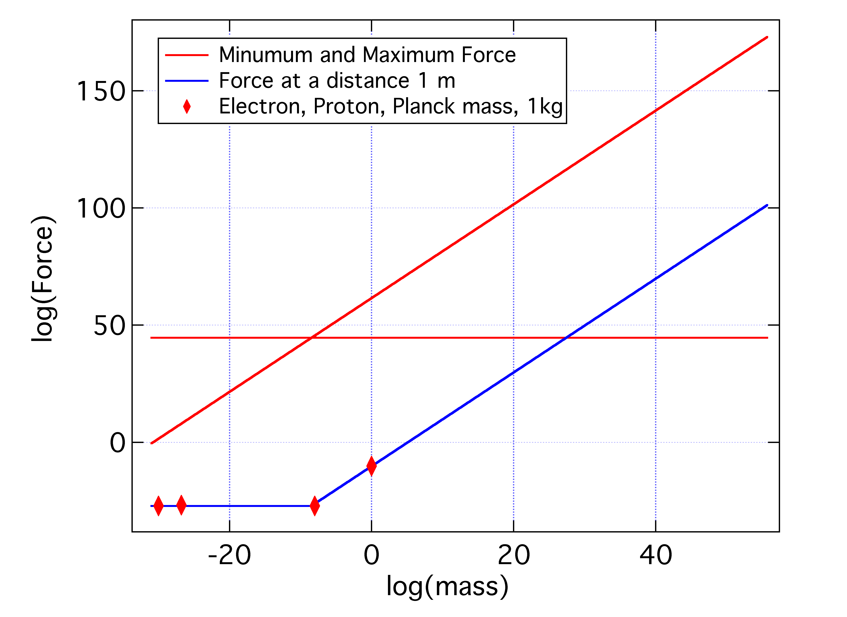

Fig. 3 Force as a function of the mass. The forces shown in red are found as a function of the space parameters that have quantum character. The force in blue is the force of an object at a distance of 1 m. The four markers are for the electron, the proton, an object with a mass equal to the Planck mass and an object with a mass 1 kg (equal to gravitational constant $G=6.53×{10}^{-11}$).

The force of an electron and a proton at a distance of 1 m is found using the Coulomb constant and the charges ($F=k{e^{2}}/{r^{2}}$). The force of an object of 1 kg at a distance of 1 m ($F=G{m^{2}}/{r^{2}}$) is found using the gravitational constant and the mass. Using the approach of our work we can find all these forces and rather than using four parameters ($k, e, G, m$) we use only the mass, thus removing the difference between the gravitational and nongravitational forces. (note that we do not need the Coulomb’s and gravitational constants)

**Conclusions**

Einstein himself in the General Theory states that the speed of light cannot have an omnipotent role as in the Special Theory. Also the relation Principle-Law emphasizes that in the Special Theory, similarly to Classical Mechanics, the role of the Principle of Relativity is limited because it is legitimized only in a straight line which means that we cannot hope to have a form of the law of energy conservation which is independent of the form of the motion. These considerations and the fact that Einstein’s conservation law considers energy as a continuous quantity do not offer the possibility to consider it valid in Quantum Mechanics.

Oct, 2016